# Introduction

@WeRateDog

Analyzing and Visualization Data

|  |  |  |  |  |  |  |
| --- | --- | --- | --- | --- | --- | --- |
| @WeRateDogs is famous tweeter account for share images for cute and funny doges the account is do some rates those doges and write funny comments on the photo of people dogs we collect some from multiple data source and I do some cleaning and wrangling methods and also use visualization and analysis tools like matplot to answer some wondering questions like whom famous dog !!**Top Five Favorite Dog** |  | |  | | --- | |  | |  | |  | |  | |

|  |  |  |
| --- | --- | --- |
|  |  | Doggo He is got more than 164005 likes from users is I think he is famous dogs. |
| Puppo This second dog in our list his got 140166 likes from Users. |  |  |
|  |  | Stephan His 3rd famous liked dog in our list his rate 13/10 and he got more than 126822 likes. |
| 4.Jamesy This is 4th dog in our list it is got 121776 likes and his rate 13/10 |  |  |
|  |  | Doggo This last dog in our top 5 his favorite count is 121151  . |

**2. What is most popular Dog Kind over all dataset?**

I used histogram to find what is popular kind between all dog.

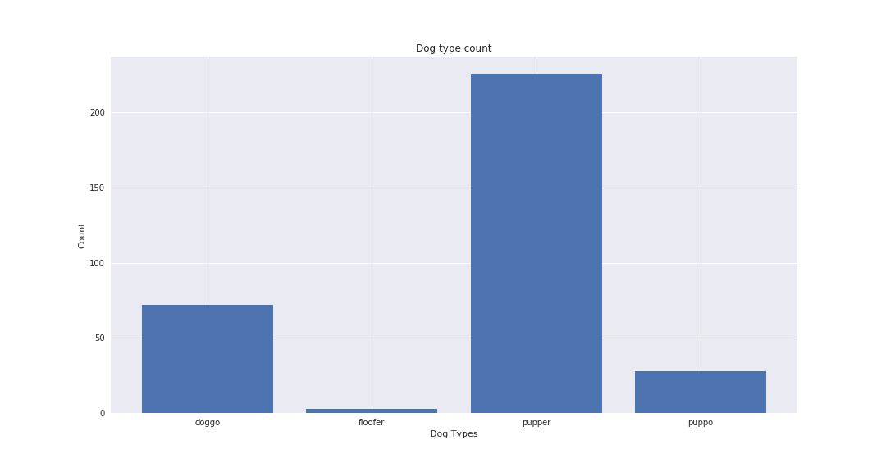

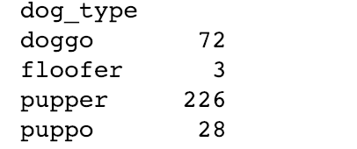

The Popular dog is pupper is comes 226 times over the time.

In this section I try to compare count of retweet vs favorite for each months of years and I find the trends is goes up and positive and increase each month for retweet while there A multimodal distribution.

**3. What is Forecast or time counts between the favorite and retweet over year?**

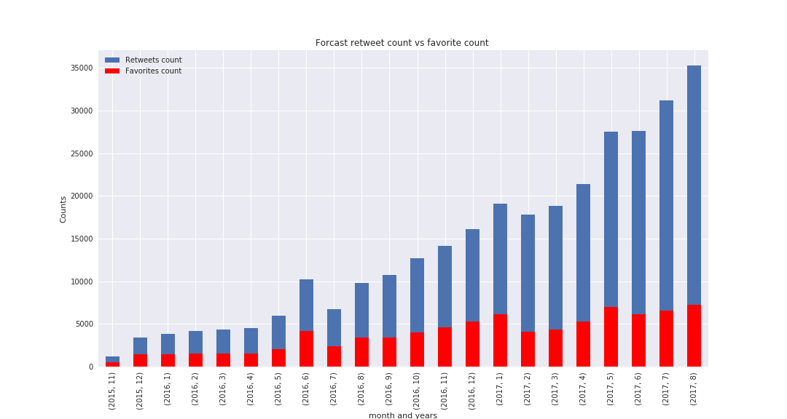

Using scatterplot to figure out the relation kind between the favorite and retweet count the plots shows there is high positive correlation between variables except some of values it shows as outliers and the correlation value between them is 0.9296

1. **What is Relation between favorite count and retweet?**

